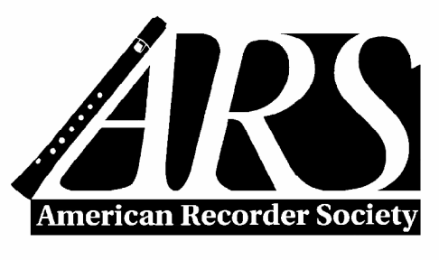

PO Box 480054, Charlotte NC 28269-5300
Tollfree: 844-509-1422 / Phone: 704-509-1422 / Fax: 866-773-1538
director @americanrecorder.org

Application For Weeklong Recorder Workshop Scholarships
(see separate application for Weekend Workshops)

You may also apply online at https://americanrecorder.org/scholarships

ARS scholarships are for applicants who primarily play recorder. You must be an ARS member to apply; if you are not a member, you make take advantage of our half-price special of $25 for the first year.

Applications must be postmarked by May 15 of current year.

Send or email your application, to the street address or email address above. You may use the space allotted on this form for the essay or use a separate sheet, but do not exceed one page. Application materials cannot be returned. You must sign the written application. Please do not send recordings; they are not required.

Name: _______________________________________________ ________________

Address:

City: ______ State/Prov: Zip+4/Postal:

Phone number: Mobile: Home: __________

Email: Chapter affiliation (if any) ______________________

If under 21, age: _____________

Workshop(s) you are applying to attend:

First choice Second choice

If Amherst or San Francisco Early Music Society workshop, which week? _____________________________

Amount requested (up to $600): __________ Total registration cost: $_________ Deadline: ____________

Where did you hear about ARS scholarships?

Other factors being equal, if the number of qualified applicants is large, priority will be given to those who have not received previous ARS scholarships.

Please note that any ARS scholarship must be used within the ARS fiscal year for which it was awarded before August 31.

A report detailing your experience is required within four weeks of the event. This way ARS donors can see how their funds have been used for a great cause.

Section A: Level of Expertise
List recorder-related schools, workshops or classes you have attended, as well as teachers with whom you have studied recorder. You may attach separate page. Give dates and degrees earned, if any.

Section B: Applicant's Essay (Important)
In the space provided, or on a separate page, please state why you would like to attend a summer workshop and why you are seeking financial aid to attend that workshop. Include how you expect to benefit, as well as ways in which you will share your experience with others, i.e. teaching, performing, planning a workshop, hosting a guest performer or master class. If you are a student, include where you are in school, and describe your educational goals.

Section C: Letters of Recommendation
Two letters are required. You may either mail us sealed letters of recommendation with your application OR you may have your teacher mail or email us their recommendation from their own email account. List information about your references below. Letters should address the following: how long and in what capacity the reference has known you, musical merit and promise, desire for personal enrichment, and potential benefit to others of your experience.

1. Name ______________________________ Phone: _________________________

Email ______________________________

2. Name ______________________________ Phone: _________________________

Email ______________________________

_____________________________________ _________________________
Applicant's signature Date

Updated 3/2023

