Have you ever counted down to an event? Maybe even as a child, you counted the days to your birthday or Christmas? I am counting down the days to some of the most exciting workshops being offered. I sit and plan my fantasy workshop schedule with the Spring AR—then reality sets in, summer approaches, and I begin to make more realistic choices! I decide where I want to go, with whom I want to study and I even get to see my name appear on faculty rosters. We are all very fortunate for the wealth of talent around us.

The ARS is fortunate for the loyal support from its talented membership. We have 14 hardworking Board members and many non-Board members helping to carry out the many projects happening within the ARS.

Being a Board member has taught me the value of the ARS and the need to be involved in meeting the needs of our members in an ever-changing world. Working with the ARS Board of Directors has been a meaningful and important commitment in my life; I am lucky to work with some of the most engaging and passionate recorder players out there. Three such people are retiring Board members Ann Stickney, Bonnie Kelly and Matt Ross.

Matt came on the Board at the same time I did. Over the past seven years, Matt has helped champion many projects including the inception of the Chapter Liaison program. He then tackled a much-needed revision of the ARS Policy Book and By-Laws. His legal expertise has been invaluable.

Ann has guided the ARS by way of her financial background. Not only had she served the ARS for eight years previously—but, when the ARS again needed a treasurer, she answered the call without hesitation. Her expertise with the ARS budget will be something for future treasurers to emulate.

Bonnie loves welcoming new members to the ARS family, personally sending all new members greetings and working to pair them with local chapters. Her warmth and down-to-earth manner have made each new member welcome. Over the past eight years, she has also coordinated our events at the Boston (MA) Early Music Festival. Having her on the ground there has been an invaluable asset for the ARS.

Bonnie also served on the Search Committee to find our new Administrative Director (AD). Both Ann and Matt worked with retiring Administrative Director Kathy Sherrick and the Executive Committee on the new AD transition and the move of our office to Charlotte, NC.

Personalities such as Ann, Bonnie and Matt are hard to find. Their commitment to the organization and to the recorder is hard to replace. It has been a pleasure working with them. On behalf of the ARS, the Board of Directors and the members at large, I thank them for their years of service and wish them much happiness.

The Society has started counting down to another Board election in 2016. There will be several seats to fill as we say goodbye then to others who have been real worker bees for the ARS. I encourage each of you to consider serving on the ARS Board. Being a Board member is a commitment of time and talent. It is a chance to be on the ground floor, creating opportunities for the recorder community in North America. If you want to know more, please contact any Board member. Our e-mail addresses are on the ARS website—we love to talk about what we do. You don’t have to have a college degree in music to serve on the Board of the ARS.

You don’t have to play as fast as Hanneke van Proosdij, or even need to play a contra bass recorder, to serve on the Board of the ARS.

You only need a willingness to be involved and a soul generated by the love for all things recorder.—Inspired by Martin Luther King, Jr. In every community, there is work to be done….In every heart; there is the power to do it.—Marianne Williamson
- Laura Kuhlman
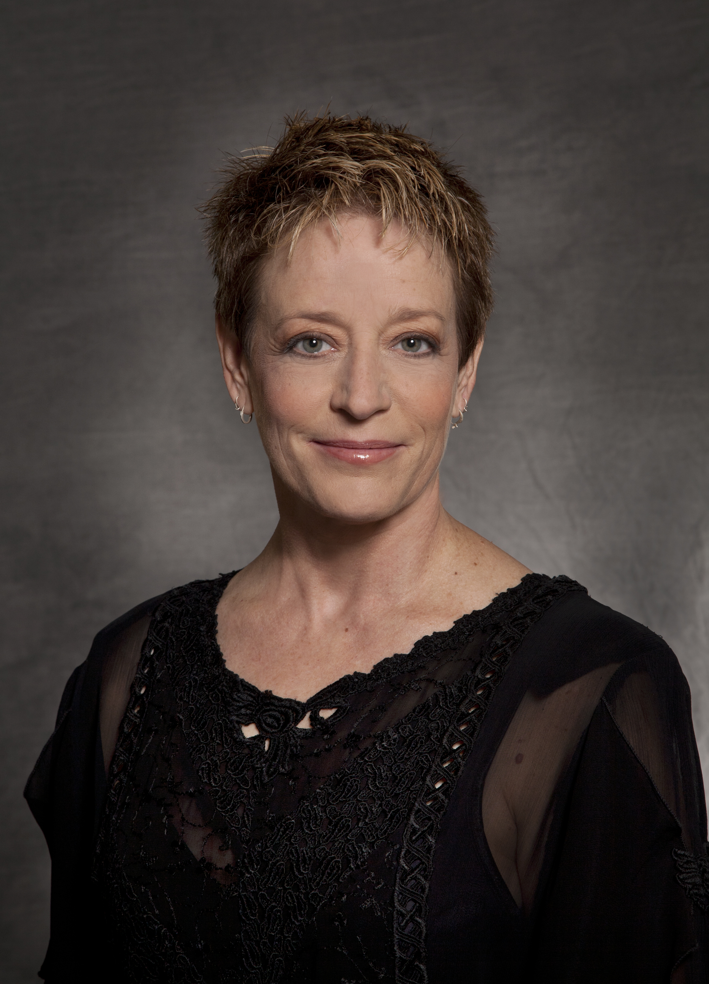
Hanover, New Hampsh

