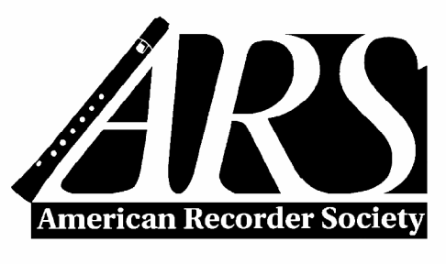

PO Box 480054, Charlotte NC 28269-5300
Tollfree: 844-509-1422 / Phone: 704-509-1422 / Fax: 866-773-1538
www.AmericanRecorder.org

Application for Margaret DeMarsh
Weekend Workshop Scholarship

Applications are accepted at any time for weekend workshops (those of four days or less), at least two months before funding is needed. ARS scholarships are for members who primarily play recorder.

Send your application, with the required recommendation letters enclosed, to the address above. Please fill out the information below completely and legibly. You may use the space allotted on this form for the essay or use a separate sheet, but do not exceed one page. Application materials cannot be returned. The application must be signed. Please do not send CD’s or tapes.

Name: ____________________________________________________________________

Address: ____________________________________________________________________

City: ______________________ State/Prov: _________ Zip+4/Postal: _____________

Phone number: Day: _______________________ Evening: _____________________

Email: _____________________________________

Chapter affiliation (if any) ______________________

If under 21, age: ________________

Workshop(s) you are applying to attend:

First choice ________________________ Second choice __________________________

Where did you hear about ARS scholarships? _________________________________________

Other factors being equal, if the number of qualified applicants is large, priority will be given to those who have not received previous ARS scholarships.

Please note that any ARS scholarship must be used within the ARS fiscal year for which it was awarded before August 31.

A report detailing your experience is required within four weeks of the event. This way ARS donors can see how their funds have been used for a great cause.

Section A: Level of Expertise
List recorder-related schools, workshops or classes you have attended, as well as teachers with whom you have studied recorder. Give dates and degrees earned, if any.

Section B: Applicant's Essay (Important)
In the space of one page, please state why you would like to attend a summer workshop and why you are seeking financial aid to attend that workshop. Include how you expect to benefit, as well as ways in which you will share your experience with others, i.e. teaching, performing, planning a workshop, hosting a guest performer or master class. If you are a student, include where you are in school, and describe your educational goals.

Section C: Letters of Recommendation
Enclose two letters of recommendation with your application. List information about your references below. Letters should address the following: how long and in what capacity the reference has known you, musical merit and promise, desire for personal enrichment, and potential benefit to others of your experience.

1. Name ______________________________ Phone: ________________________

2. Name ______________________________ Phone: ________________________

_____________________________________ __________________________
Applicant's signature Date

Updated 2017

