The ARS is pleased to welcome Alice Derbyshire and Greta Haug-Hryciw as new members of the Board. These appointments, which arose out of retirements and term expirations of previous members, will run until August 2016.

Both women are eminently qualified for the job. They are well-known and well-regarded in the recorder community, and have both shown a high level of leadership in their work.

I first met Alice at an early music workshop at Hidden Valley in California, and have since encountered her in many other such events in North America and Europe. In her playing and in her participation she shows a great passion for the recorder and its music. In her home state of Texas, her enthusiasm has been translated into much hard work on behalf of recorder players. She has served twice on the board of directors for the highly successful Texas Toot recorder festival, and for the period 2006-2009 was its President. She is also currently the President of the Dallas Recorder Society. Alice also plays mandolin, and again her passion was translated into service on behalf of that community, notably in organizing a concert tour for the Dutch mandolin orchestra “ONI”. This collaboration led to two tours of the Netherlands for Alice’s recorder group. Alice also has business experience, notably in the biofuels industry.
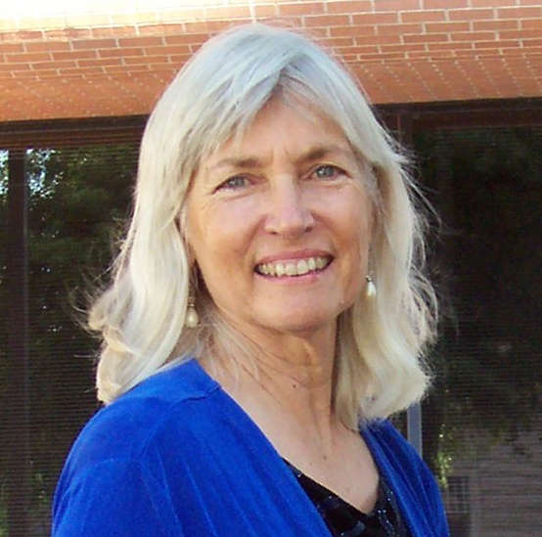

Greta is a one-woman recorder tornado that ever whirls throughout California. I was first swept up by her when she was serving under Tom Zajac as Assistant Director of the San Francisco Early Music Society’s MedRen workshop. She has continued a long and close association with SFEMS in their annual two-week Recorder Workshop and in other capacities. Greta has been very active in the promotion of recorder orchestras, serving as Co-director/Conductor of the American Recorder Orchestra of the West, the Barbary Coast Recorder Orchestra, and the Mid-Peninsula Recorder Orchestra. She is also a frequent guest conductor at local recorder chapters in California. Greta has had extensive experience in business, as manager of her husband’s photography business, advertising coordinator for SFEMS, and more recently as assistant in Lazar’s Early Music shop.
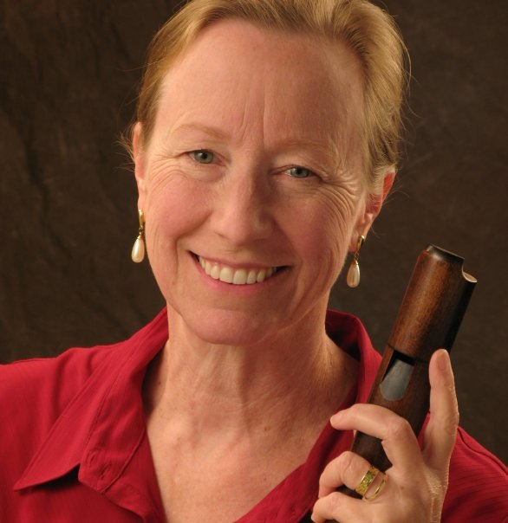

Last, but by no means least, both appointees are great fun to be around. The ARS Board looks forward to a productive year of contributions from these talented and hard-working women.

Tony Griffiths,
ARS Secretary

