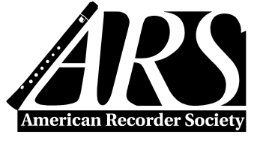

AMERICAN RECORDER
ADVERTISING INSERTION ORDER FORM
2017—Vol. LVIII

Advertiser:
Address:
E-mail:
Signature

Date

RESERVATION FORM I authorize the insertion of advertising in American Recorder, as indicated below.

Indicate issues desired for advertising:

- Spring 2017
- Summer 2017
- Fall 2017
- Winter 2017

Advertising Size/Cost in American Recorder Magazine – see rate card for details

Size:
Color:
Cost per issue:

Email Advertising Materials to:
Gail Nickless
editor@americanrecorder.org

cc: advertising@americanrecorder.org

Check here if you prefer to be invoiced and pay online
or via check

Or, to pay by credit card through the ARS office:

____________________________
VISA / MC / AMEX / Discover

Expiration Date: ____________ 3 digit # on back _______

__________________________________________
Signature of cardholder:
CLEARLY PRINT NAME as it appears on Card:

INSTRUCTIONS
Please Email Insertion Orders to
Publishing Schedule  Name of Issue | Insertion Order Deadline | Ad Materials Due | Publication  Date | Delivery Date (approx.)
SPRING - March | Dec 15 | Jan 1 | Feb 15 | Mar 1
SUMMER - June | Mar 15 | April 1 | May 15 | June 1
FALL - September | June 15 | July 1 | Aug 15 | Sept 1
WINTER - December | Sept 15 | Oct 1 | Nov 15 | Dec 1
Susan Burns, American Recorder Society
advertising@americanrecorder.org
PO Box 480054
Charlotte, NC 28269-5300
Phone: 704-509-1422, Tollfree 844-509-1422

